**Revision and Design Review (DR) History**

|  |  |  |  |  |  |
| --- | --- | --- | --- | --- | --- |
| Revision | Date | ECO | Changes | Modified By | Approved By |
| 1 | 21-Apr-17 | Created the VLAN on firewall port | Original | Ulkesh Gimonkar |  |
| 2 |  | Make the Policies for each VLAN | Original | Ulkesh Gimonkar |  |
| 3 |  | Arrange the department wise switches. | Original | Ulkesh Gimonkar |  |
| 4 |  | Make the connectivity from Firewall to VLAN | Original | Ulkesh Gimonkar |  |

Contents

**1.** **Purpose** 3

**2.** **Scope** 3

**3.** **Definitions and Abbreviations** 3

**4.** **Responsibilities** 3

**5.** **Method** 3

**6.** **Appendix A** 4

1. **Purpose**
   1. What is the purpose of this procedure: - Procedures to configure the Internet Security on Firewall into JiBe office.
2. **Scope** 
   1. Write the scope: - To created more secure network and separate the network by Department and their activities.
3. **Definitions and Abbreviations**
   1. Example – Created VLAN in firewall and to make the separate networks structure in office.
4. **Responsibilities**
   1. Write all the responsibilities for specific people/role

|  |  |
| --- | --- |
| **Responsibility Description** | **Responsibility** |
| 1) Create VLAN in Fortigate Firewall. | To separate the network which will not be communicate with each other’s. |
| 2) To make a separate switch with the separate groups. | To make more secure for internet access and their usage. |

**Installation Method**

1. Configure and activate the Firewall ports to create VLAN.
2. Created and configure the VLAN as per department in Mumbai Office.
3. Configure the Web and Applications policies on Firewall for respective departments.

1. Block the all access of internet and shared drives of the local servers.

 Create the Policies to Block the all sites and Shared drive for internal as well as external.

Create one policy to allow the users to use the JiBe official’s sites only like – JIT, OCA, Talent pro. Naukari site only for HR team.

Fortigate Firewall VLAN configuration;

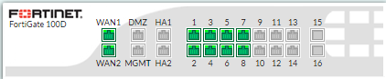

Developer

HR_Admin

Tester

Account

Support

IT

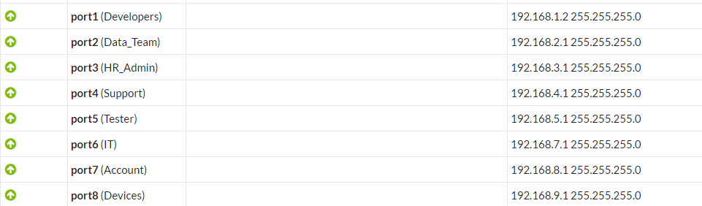

***For any clarification, do not hesitate to contact IT Dept. for assistance.***